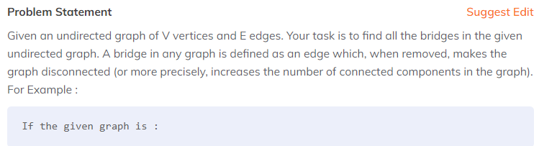

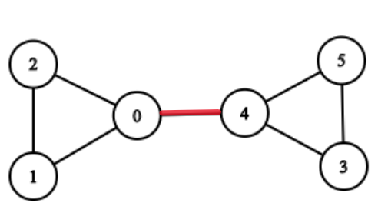

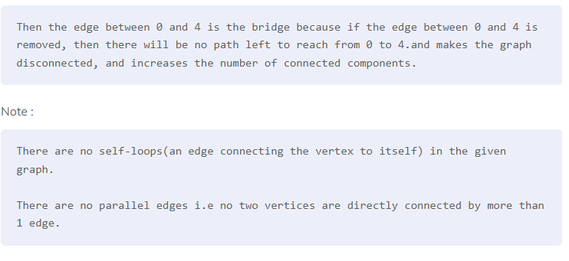

**Sample Input 1 :**

2

5 4

0 1

3 1

1 2

3 4

3 3

0 1

1 2

2 0

**Sample Output 1 :**

4

0 1

1 2

1 3

3 4

0

**Explanation For Sample Input 1 :**

For the first test case, the graph will be represented as

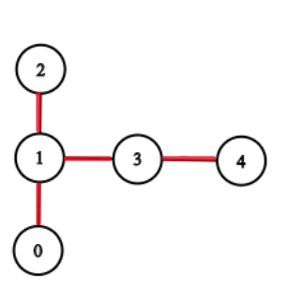

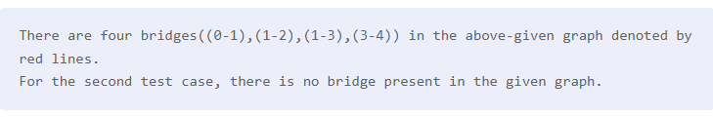

##### Sample Input 2 :

1

6 7

1 2

1 0

0 2

0 4

5 4

5 3

3 4

##### Sample Output 2 :

1

0 4

##### Explanation For Sample Input 2 :

For the first test case, the graph will be represented as



There is only one bridge((0-4)) in the above-given graph denoted by red lines.